MEASURING SUCCESS IN TALENT MANAGEMENT

1.INTRODUCTION:

1.1 Overview

Talent management is how employers recruit and develop a workforce that is as productive as possible and likely to stay with their organization long term. When implemented strategically, this process can help improve the overall performance of the business and ensure that it remains competitive.

1.2 Purpose

The purpose of talent management is to identify, recruit and hold on to people who drive the success of your organisation. It’s a top priority, strategic process for forward-looking people companies who understand that their company performance depends on their workforce. Performance and talent management is a key function of the morden HR department.

2 Problem Definition & Design Thinking

2.1 Empathy Map

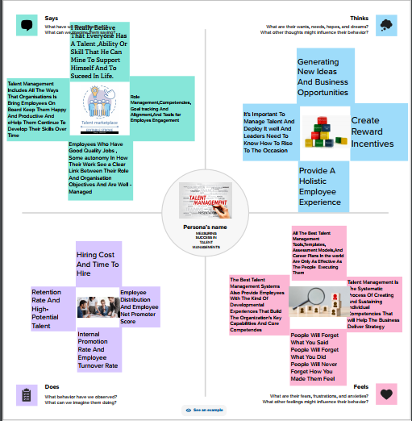

2.2 Ideation & Brainstorming map

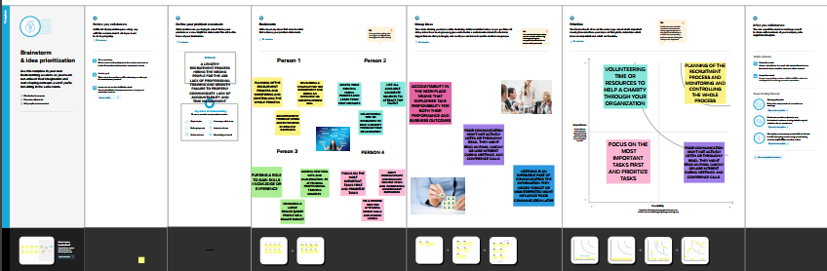

3 RESULT

3.1 Activity & Screenshot

Dashboard 1:

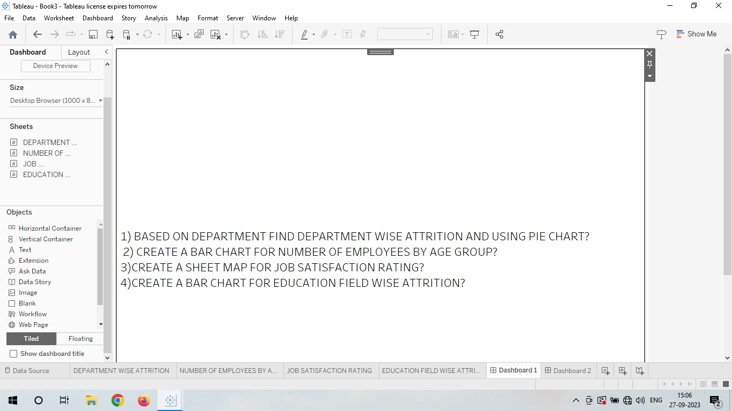

Dashboard 2:

EMPLOYEE PERCENTAGE BASED ON THEIR EDUCATION USING PIE CHART

A pie chat is a circular statistical graphic which is divided into slices to illustrate numerical proportion. In a pie chat, the arc length of each slice is proportional to the quantity it represents.

In our dataset, we are using Employee count and education column to understand the spread of employee based on the education.

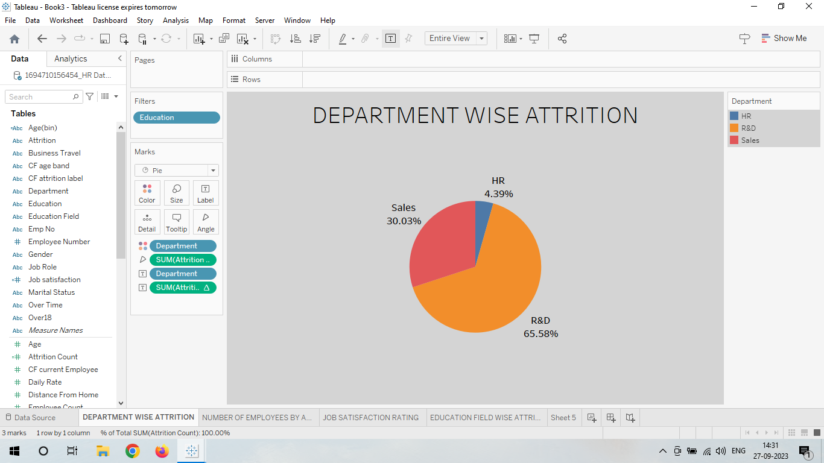

Dashboard 3:

HISTOGRAM

A histogram is a graph that shows the frequency of numerical data using rectangles. The height of a rectangle (the vertical axis) represents the distribution frequency of a variable.

In our Dataset, We are using Age column and percentage salary hike column for understanding the relation or distribution of salary hike based on age.

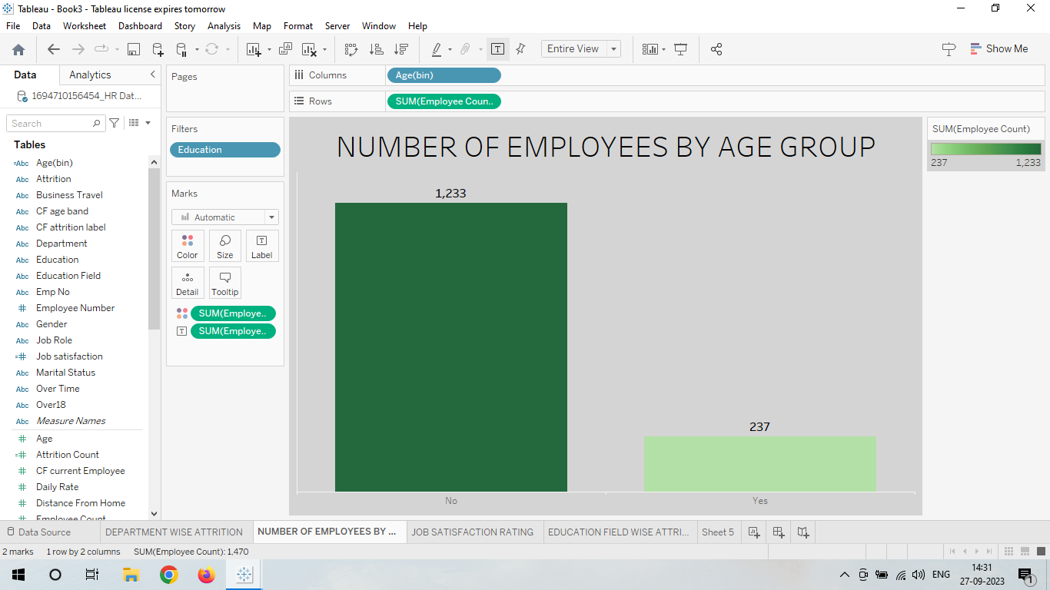

Dashboard 4:

LOLLIPOP CHAT

A lollipop plot is basically a bar plot, Where the bar is transformed in a line and a categoric variable.

In the dataset, we are using job role and job satisfaction for creating the lollipop chart.

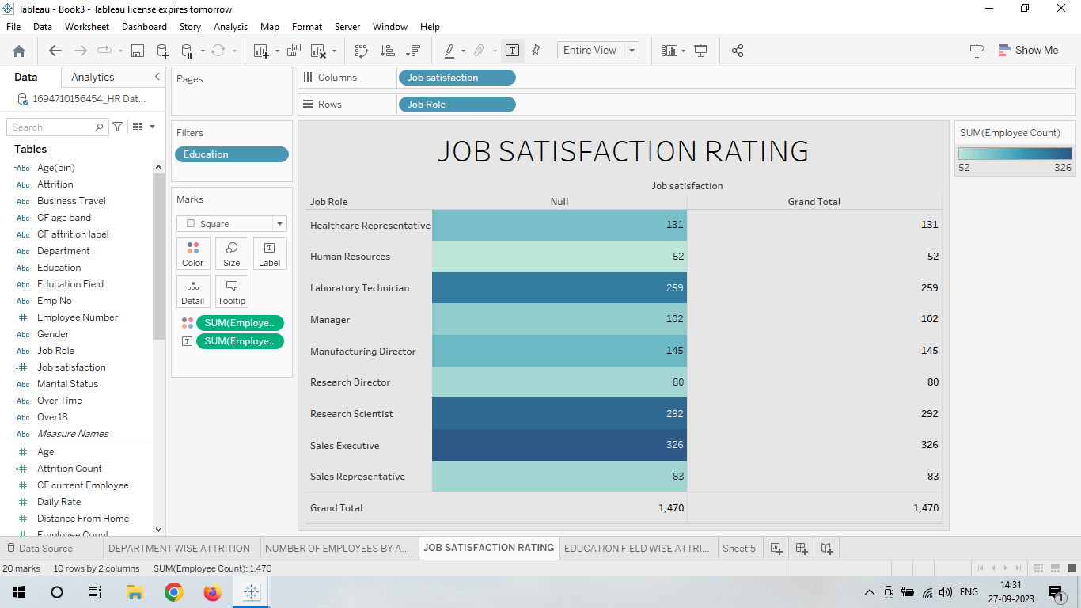

Dashboard 5:

FUNNEL CHART

A funnel chart is a graphical representation used to visualize how data moves through a process. In a funnel chart, the dependent variable’s value diminishes in the subsequent stages of the process. Funnel charts are widely used to represent sales funnels, recruitment, and order fulfilment processes.

In the above dataset, we are using attrition count and education field the distribution of employee frequency according to education.

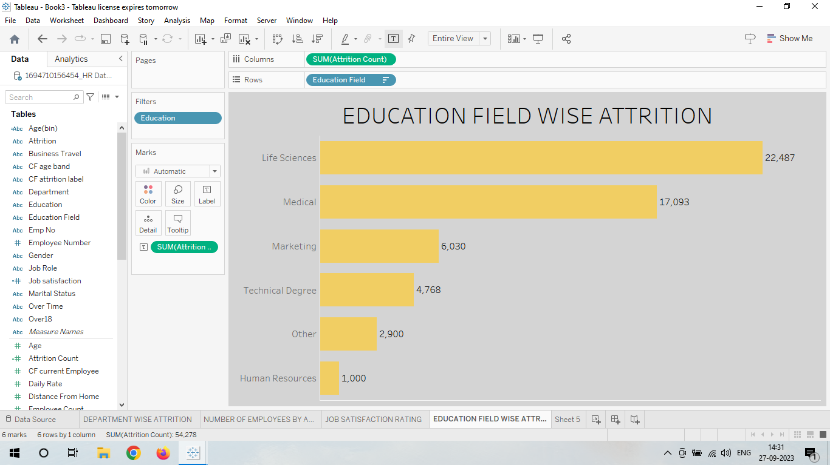

Dashboard 6:

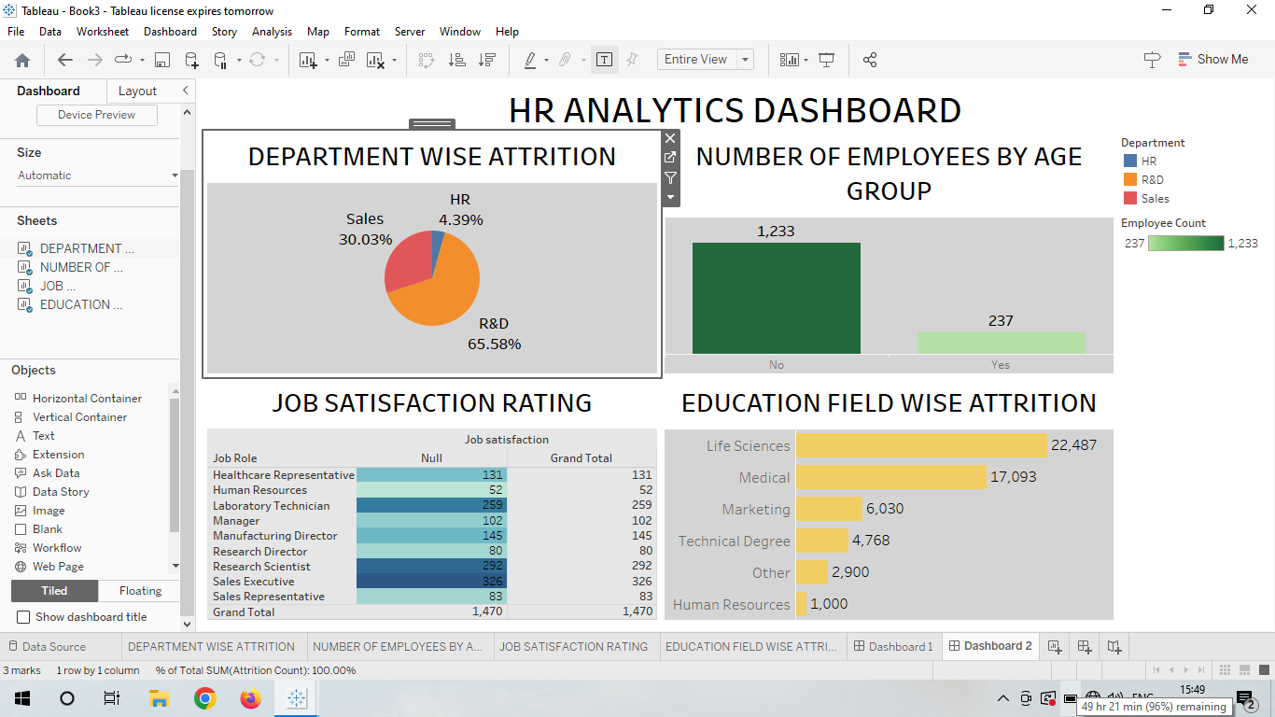

Dashboard 7:

STORY BOARD

A data story is a way of presenting data and analysis in a narrative format, with the goal of making the information more engaging and easier to understand. A data story typically includes a clear introduction that sets the stage and explains the context for the data, a body that presents the data and analysis in a logical and systematic way ,and a conclusion that summarizes the key findings and highlights their implications. Data stories can be told using a variety of mediums, such as reports, presentations, interactive visualizations, and videos.

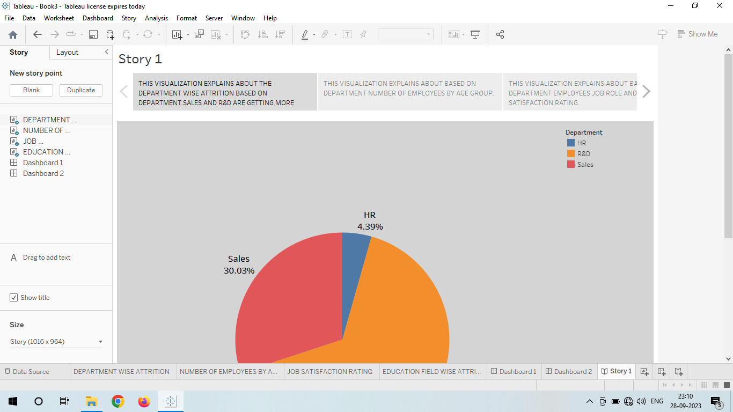

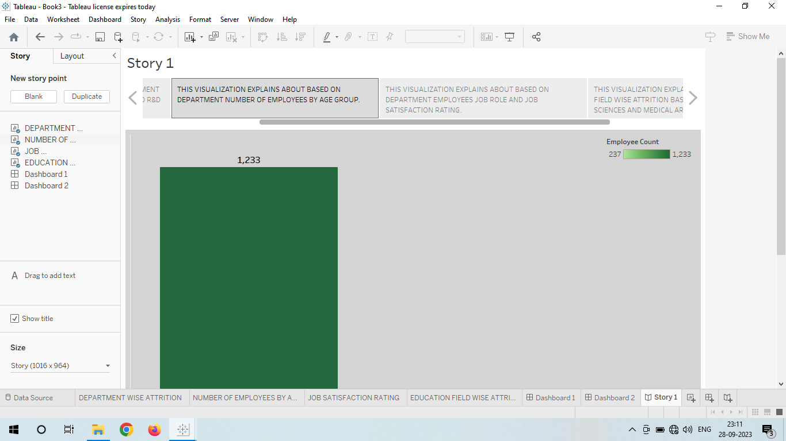

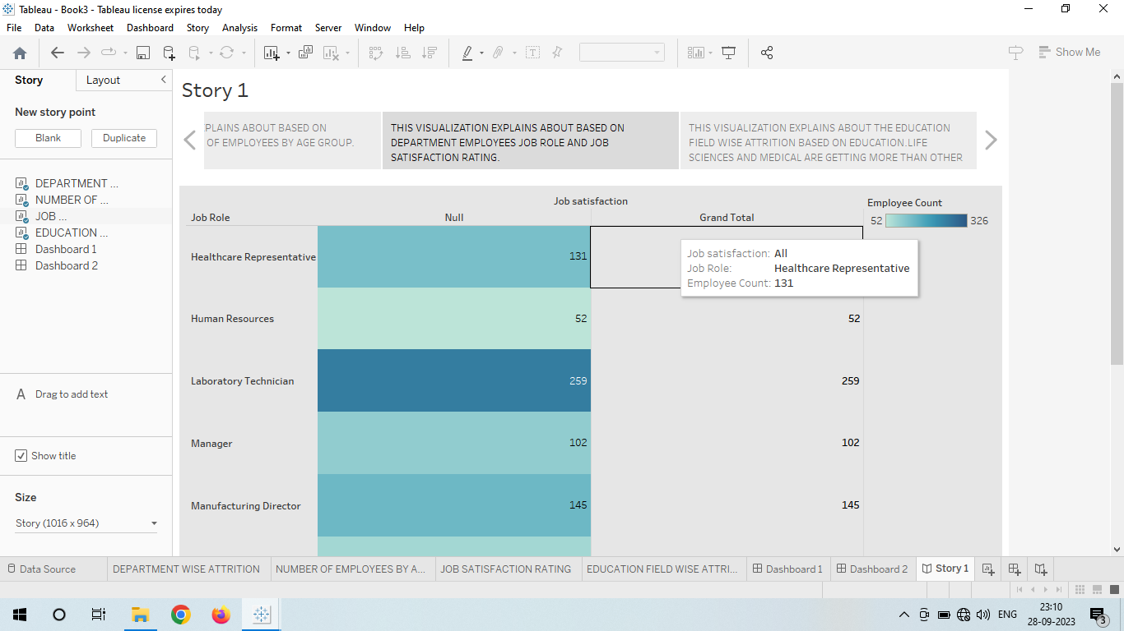

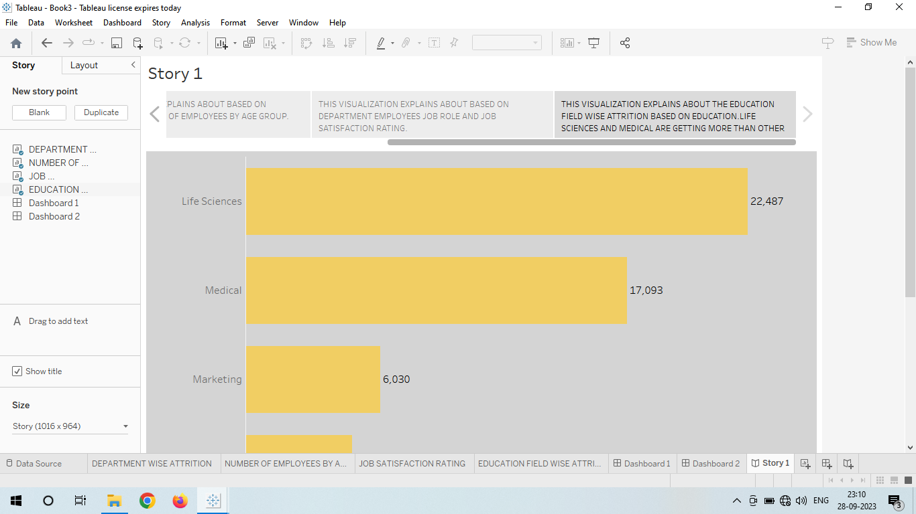

4. ADVANTAGES & DISADVANTAGE

ADVANTAGES:

* Help in ascertaining the right person is deployed in the right position.
* Contributes in retaining their top talent.
* Better hiring by hiring assessments.
* Helps in understanding employees better and shaping their future.
* Promotes effective communication across different disciplines.

DISADVANTAGES:

* The implementation of talent management program could be expensive in terms of time, resources and financial costs.
* Lack of support from line managers can impede the level of commitment from employees.
* A core drawback of talent management is, it can contribute in raising the conflicts between HR and management by not reaching to proper agreement or consensus.

5. APPLICATION

Retailing have been developed for each of those areas.

EXAMPLE:

Applications include finances, marketing, manufacturing and human resources

6. CONCLUSION

* Talent management in an organization aims at ensuring employee recruitment, training and development, performance reviews and their compensation.
* Working towards enhancing a good talent management system in the organization ensures these components of human resources contribute to the success of the organization.
* The advantages that the components bring to the organization also outweigh the disadvantages considering organizations benefit from these approaches.

7. FUTURESCOPE

* There are three crucial tipping points that will shape the future of talent management. These include (1) a responsive and reactive approach to talent management, (2) little consideration of how careers are changing, and; (3) it cannot be the catch-all practice of the past.
* In its current state, talent management will not rise to future challenges. Only 13% of HR leaders rate their talent management practices as “excellent,” while 70% of HR leaders rate their organization’s ability to address their talent needs as “mediocre”.
* We propose four shifts for talent management to move into the next era of work that will be characterized by Al, labour shortages, work without boundaries, and workforce ecosystems.